HTML Base Element

📖 Definition
# Source: AI Source: Provided by: [Data Path: Persons Table -> ID Column: 1, Name_En Column: Motasem Essam] -> From: [ChatGPT] on [5/6/2026]
The <base> element is used to define a default base URL and/or a default target for all relative URLs and resources in an HTML document.
It is placed inside the <head> element.

⚙️ Why <base> is used
# Source: AI Source: Provided by: [Data Path: Persons Table -> ID Column: 1, Name_En Column: Motasem Essam] -> From: [ChatGPT] on [5/6/2026]
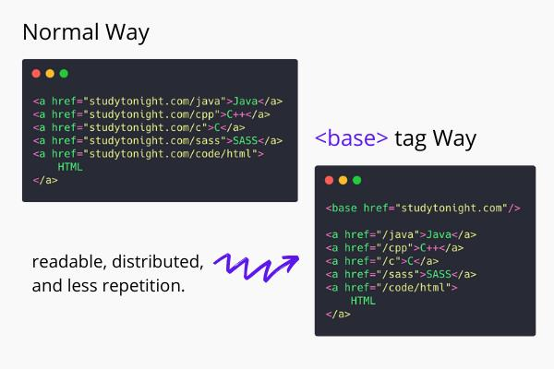
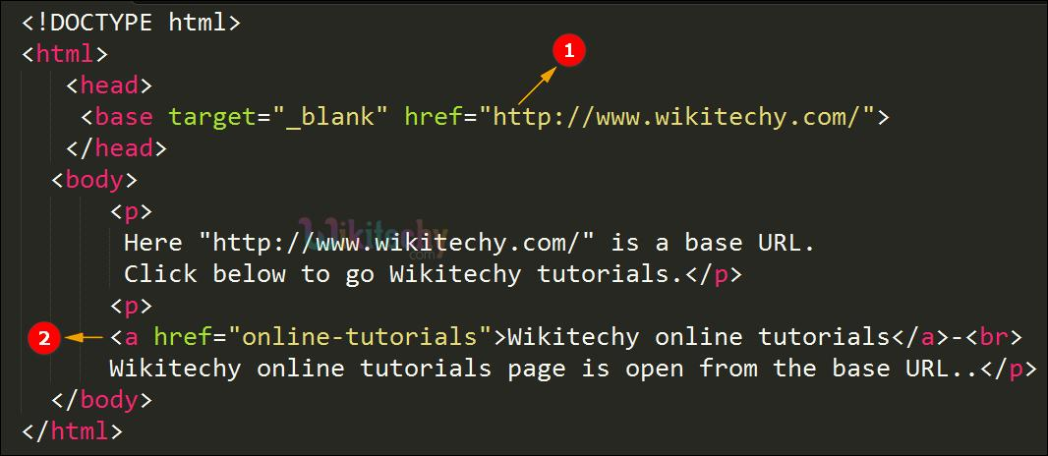
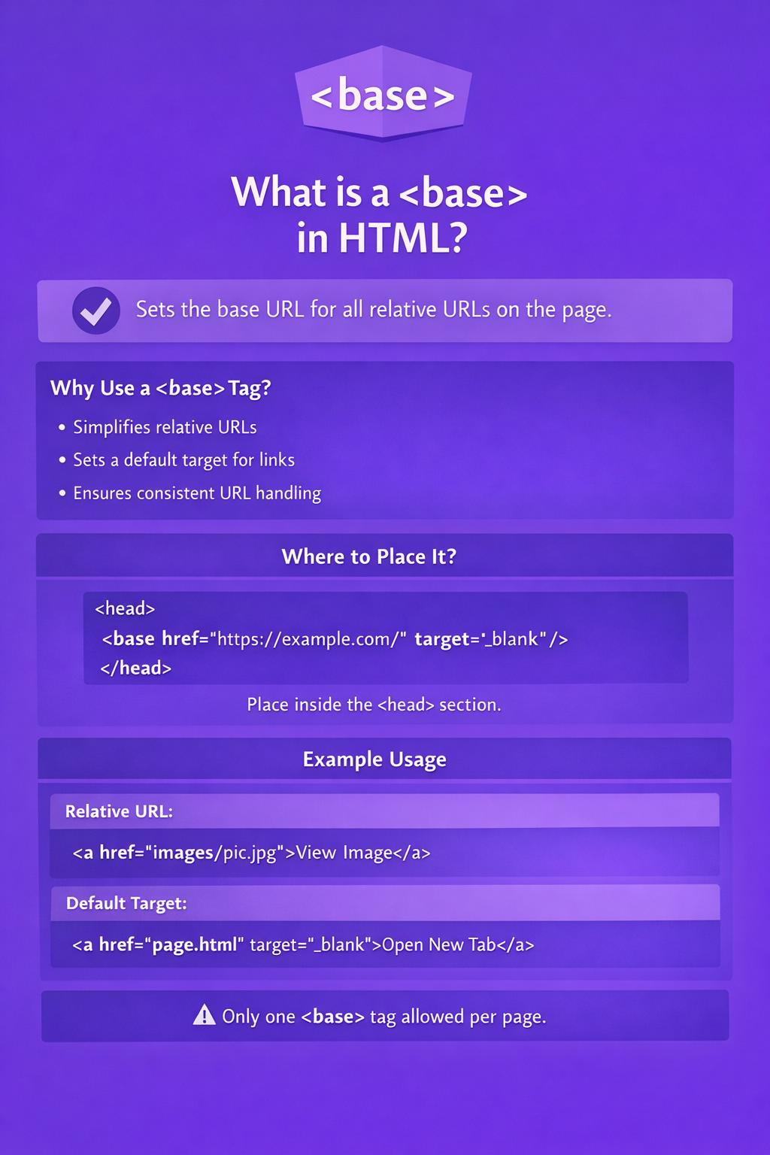
Normally, relative links are based on the current page location.
👉 <base> changes that default behavior.

🧪 Common Uses of <base> (with examples)

🌐 1. Define Base URL
# Source: AI Source: Provided by: [Data Path: Persons Table -> ID Column: 1, Name_En Column: Motasem Essam] -> From: [ChatGPT] on [5/6/2026]
📖 Description
Sets a default URL for all relative links and resources.
💻 Full Example
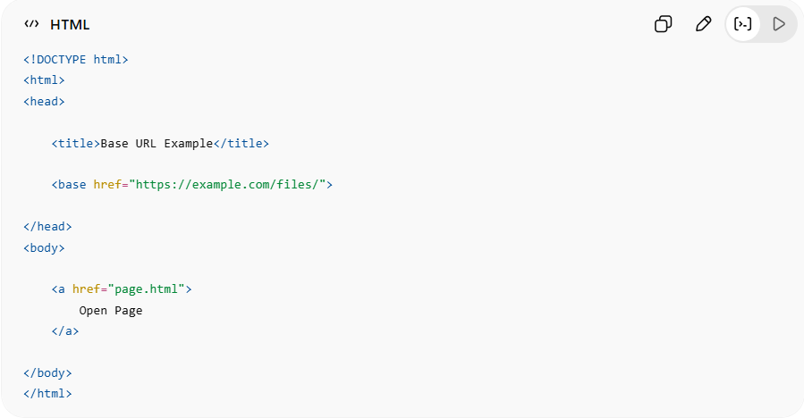
<!DOCTYPE html>
<html>
<head>
<title>Base URL Example</title>
<base href="https://example.com/files/">
</head>
<body>
<a href="page.html">
Open Page
</a>
</body>
</html>
🧠 What happens?
The browser converts:
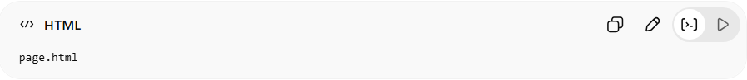
page.html
into:
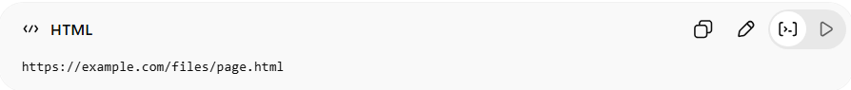
https://example.com/files/page.html
👉 Because of the <base> URL

🎯 2. Define Default Link Target
# Source: AI Source: Provided by: [Data Path: Persons Table -> ID Column: 1, Name_En Column: Motasem Essam] -> From: [ChatGPT] on [5/6/2026]
📖 Description
Sets where links open by default.
💻 Full Example
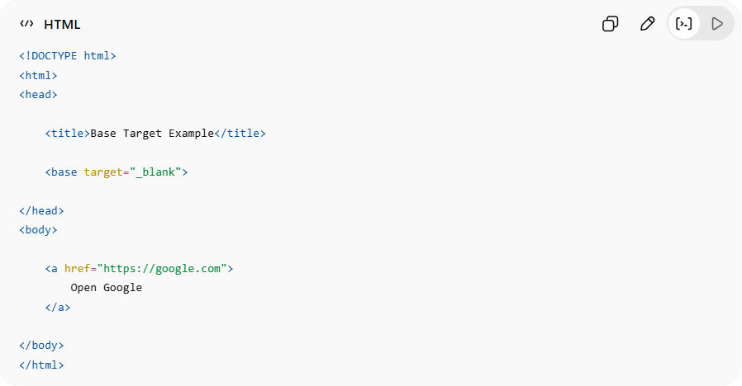
<!DOCTYPE html>
<html>
<head>
<title>Base Target Example</title>
<base target="_blank">
</head>
<body>
<a href="https://google.com">
Open Google
</a>
</body>
</html>
🧠 What happens?
👉 All links automatically open in:
- new tab/window (_blank)
Without needing:
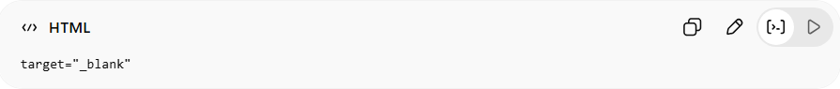
target="_blank"
on every link.

🌐 3. Base URL for Images
# Source: AI Source: Provided by: [Data Path: Persons Table -> ID Column: 1, Name_En Column: Motasem Essam] -> From: [ChatGPT] on [5/6/2026]
📖 Description
Relative image paths also use the base URL.
💻 Full Example
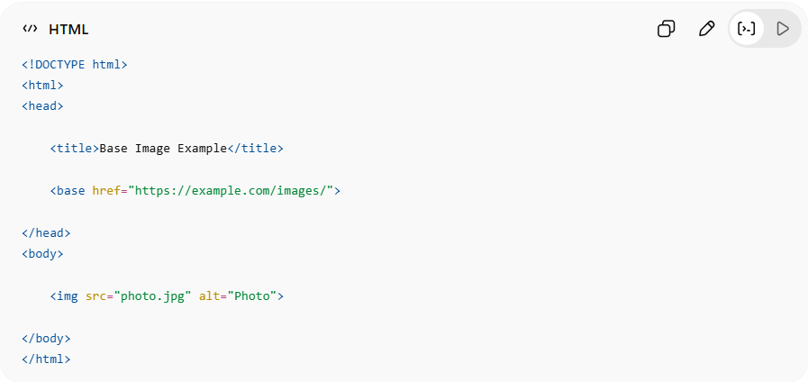
<!DOCTYPE html>
<html>
<head>
<title>Base Image Example</title>
<base href="https://example.com/images/">
</head>
<body>
<img src="photo.jpg" alt="Photo">
</body>
</html>
🧠 Browser converts:
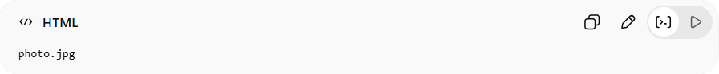
photo.jpg
into:
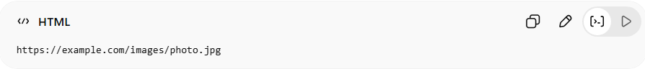
https://example.com/images/photo.jpg

⚠️ Important Rules

❗ Only One <base> Element
# Source: AI Source: Provided by: [Data Path: Persons Table -> ID Column: 1, Name_En Column: Motasem Essam] -> From: [ChatGPT] on [5/6/2026]
❌ Bad:
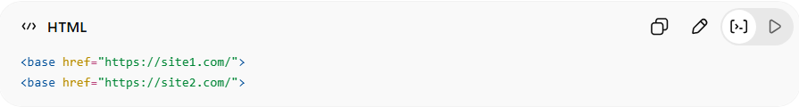
<base href="https://site1.com/">
<base href="https://site2.com/">
👉 Only the first one works.
✅ Good:
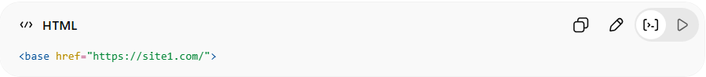
<base href="https://site1.com/">

❗ Must Be Inside <head>
# Source: AI Source: Provided by: [Data Path: Persons Table -> ID Column: 1, Name_En Column: Motasem Essam] -> From: [ChatGPT] on [5/6/2026]
❌ Bad:
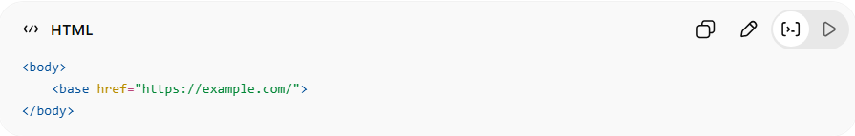
<body>
<base href="https://example.com/">
</body>
✅ Good:
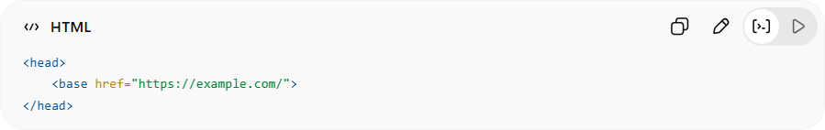
<head>
<base href="https://example.com/">
</head>

⚙️ Common Attributes
# Source: AI Source: Provided by: [Data Path: Persons Table -> ID Column: 1, Name_En Column: Motasem Essam] -> From: [ChatGPT] on [5/6/2026]
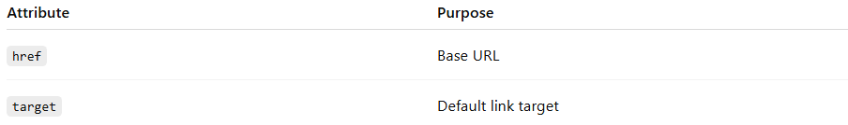
Attribute | Purpose
href | Base URL
target | Default link target

🚀 In short:
# Source: AI Source: Provided by: [Data Path: Persons Table -> ID Column: 1, Name_En Column: Motasem Essam] -> From: [ChatGPT] on [5/6/2026]
<base> = an HTML element that sets the default URL and/or default target for relative links and resources in a webpage.

